**The green transition**

**绿色变革**  
(英文部分选自经济学人20220820财经版块)

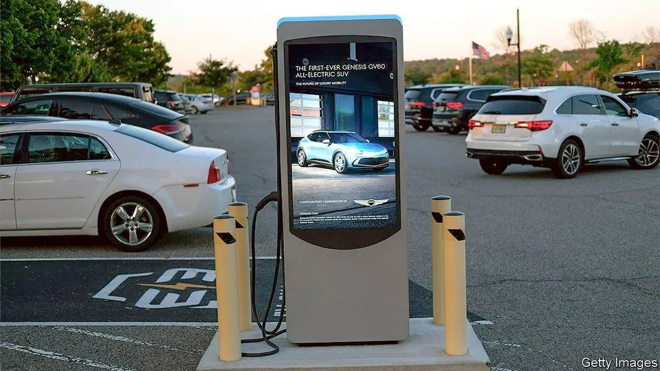

The green transition

绿色变革

Cash **guzzlers**

省油不省钱

There are better ways than subsidies to encourage electric-car use

鼓励电动车的使用，有比补贴更好的办法

**“We’re coming to Norway,” begins an advertisement for General Motors**, an American carmaker. Supposedly enraged by the Nordic nation easily surpassing America in electric vehicles (evs) per person, Will Ferrell, a comedian, **sets off over land and sea** to **deliver the challenge to Norwegians**, only to be told, after several **mishaps** along the way, that he has in fact arrived in Sweden.

**“冲鸭！挪威，我们来了！”这是美国通用汽车公司的一则广告的开头**。广告里的主人公（由喜剧演员Will Ferrell饰演）因为不忿于挪威人均电动车数量轻松超越美国，**决定前往挪威跟他们一较高下**。不过，**历经波折跋山涉水**之后，他却被告知，他实际上来到了瑞典。

I managed to get home without (further) mishap.

我总算平安回到了家。

American ev policy is similarly lost. **As part of President Joe Biden’s bid to decarbonise the economy**, the Inflation Reduction Act (ira), a recently passed infrastructure bill, offers incentives for people to purchase evs. **It comes just when other rich countries, including Britain and Germany, are about to reduce theirs,** **having reconsidered how best to encourage people to use green transport**. **The evidence suggests they are right to do so**—and that Mr Biden is **heading down the wrong road**.

同样迷失的还有美国的新能源汽车政策。**作为总统拜登减碳计划的一部分**，最近通过的一项基础建设法案——通胀削减法案（IRA）,为购买新能源汽车的人们提供了激励。**这一法案的出台的同时，其他富裕国家（如英国和德国）在重新考虑如何更好地鼓励人们使用绿色交通后，正准备减少激励措施**。**证据表明，他们的做法才是对的**，而拜登则是**误入了歧途**。

America’s first problem is protectionism. The ira offers subsidies to ev buyers, including rebates of up to $7,500 for new cars and $4,000 for used ones. For a new car to qualify, though, it must meet strict requirements. Half of the components in its battery must come from America, Canada or Mexico; by 2030, all of them will have to. At present, China controls most of the supply chain .

美国（政策）的第一个问题就是保护主义。IRA 对新能源汽车购买给予补贴，新车可享受最高达7500美元的折扣，二手车也可享受最高4000美元的补助。新车想要享受这项优惠，则需要满足严苛的要求——其一半的电池组成需要来自于美国、加拿大或墨西哥；到2030年，要求其所有的（电池组成）都来自于这些国家。而目前，中国控制了大部分的供应链。

As well as irritating America’s friends—the eu and South Korea have indicated they may challenge these restrictions at the World Trade Organisation—**such protectionism runs counter to the bill’s green goals**. The Congressional Budget Office, which assesses the tax-and-spending implications of legislation, estimates a total outlay over the next five years of $1.8bn, or 237,000 evs if all get the full subsidy—a paltry proportion of the 15m cars that were sold in America in 2021. Qidianwaikan chao xi Yitianyipianjingjixueren shame on you！

美国此举不仅惹恼了贸易伙伴们 （欧盟和韩国已经表示或将会向世贸组织提出申诉），更重要的是，**这种保护主义与法案想要推动绿色转型的目标相悖**。据负责评估法案税收和支出影响的国会预算办公室估计，如果法案的补贴被足额使用，接下来五年将会耗费18亿美元，共计补贴电动汽车23700辆，这与美国2021年销售的1500万辆汽车的数字相比微不足道。

Although prices are falling, evs are still dearer than vehicles with internal-combustion engines. That is true even after running costs are included. According to researchers at the Dallas branch of the Federal Reserve, at the start of 2021 the median cost per mile of range was $214 for an ev, compared with $104 for a regular car.

虽然价格在下降中，电动汽车仍然比燃油车更昂贵，即使算上使用成本依然如此。达拉斯联储的研究表明，在2021年初，电动汽车的每英里使用成本的中位数为214美元，燃油车为104美元。

Encouraging ev purchases does not necessarily take older vehicles off the road, points out David Rapson of the University of California, Davis. Families may, for instance, buy a subsidised ev to complement another vehicle. Norway does not use subsidies; instead, it gives ev owners **an exemption from** the heavy taxes the country levies on internal-combustion cars. As a bonus, such taxes encourage drivers to spend less on petrol and shy away from thirstier vehicles when buying a new car.

加州大学戴维斯分校的戴维•拉普森（David Rapson） 指出，对电动车的激励政策未必能真的减少现存（燃油）车的数量。已经有车的家庭或许会购买一台电动汽车作为补充。挪威不使用补贴，而是给电动汽车车主豁免在传统燃油车上才有的重税。此举还鼓励车主消费更少的汽油且在购车时避免选购“油老虎”汽车。

Retail-price subsidies also come with a high “deadweight” loss as many ev purchasers would have bought the car even without the discount. That is why countries with a higher proportion of ev sales than America are starting to bring their subsidy schemes to an end. Germany will start **winding down** its scheme from next year, before ending it altogether in 2024; Britain abolished many of its bungs earlier this year and plans to use the money to build charging infrastructure instead.

电动车零售价格补贴其实还伴随着很高的“无谓损失”。因为即便没有折扣补贴，许多电动车消费者也还是会选择购买。这就是为什么电动车销售情况比美国理想的一些国家纷纷开始叫停补贴政策。德国将从明年开始逐步取消优惠，补贴政策预计在2024年全面结束；英国在今年早些时候已宣布取消多项补贴，并计划用这笔资金修建充电基础设施。

注释：无谓损失(Deadweight loss)又为社会净损失，是指由于市场未处于最优运行状态而引起的社会成本, 也就是当偏离竞争均衡时, 所损失的消费者剩余和生产者剩余

Research from the World Bank suggests that Britain’s move is sensible. It calculates that on average $10,000 or so is required to encourage the purchase of an electric car. The same result could be achieved by just under $1,600 of spending on charging infrastructure. The most cost-effective means of promoting electric cars, however, come with a near-zero cost: China awards the country’s ev owners special “green” licence plates, allowing local governments to offer privileged access to parking or exemptions from congestion charges. America may want to keep foreign batteries out, but it could still welcome other countries’ ideas.

世界银行研究表明，英国此举是明智的。该研究计算出鼓励消费者购买电动车平均需要大约10000美元。但把平均仅不到每车1600美元的资金花在充电基础设施建设上也能够实现同等效果。然而，成本最优化下的电动车推广方式其成本几乎为零：比如中国给电动车车主发放特殊的“绿色新能源“号牌，能享有地方政府提供的停车便利特权或免交拥堵费。美国也许依然想将其他国家的电池拒之门外，但没有必要对这些国家的先进经验充耳不闻。